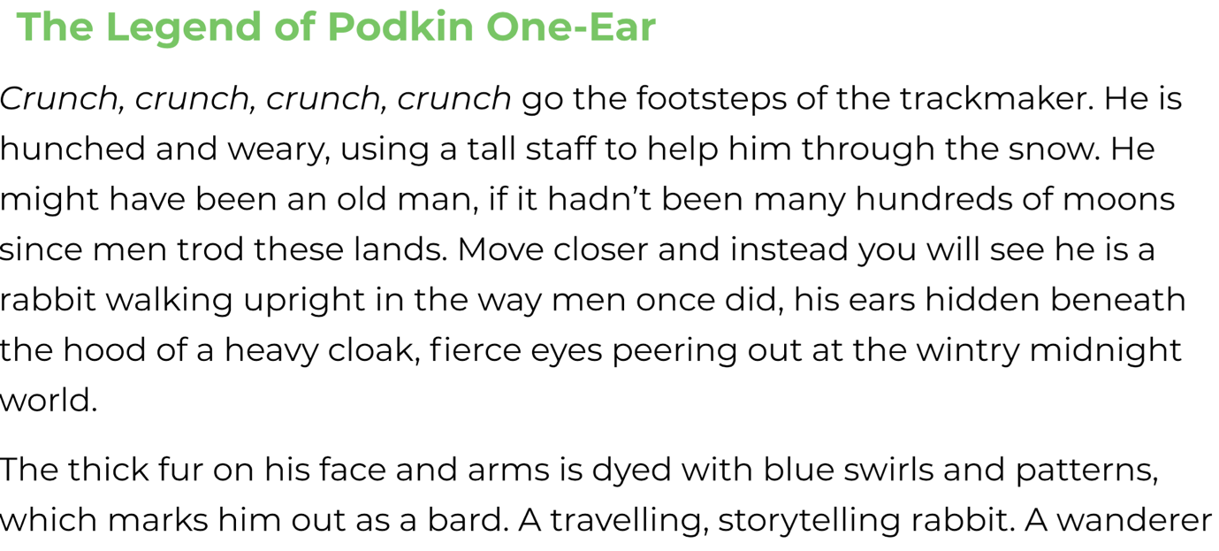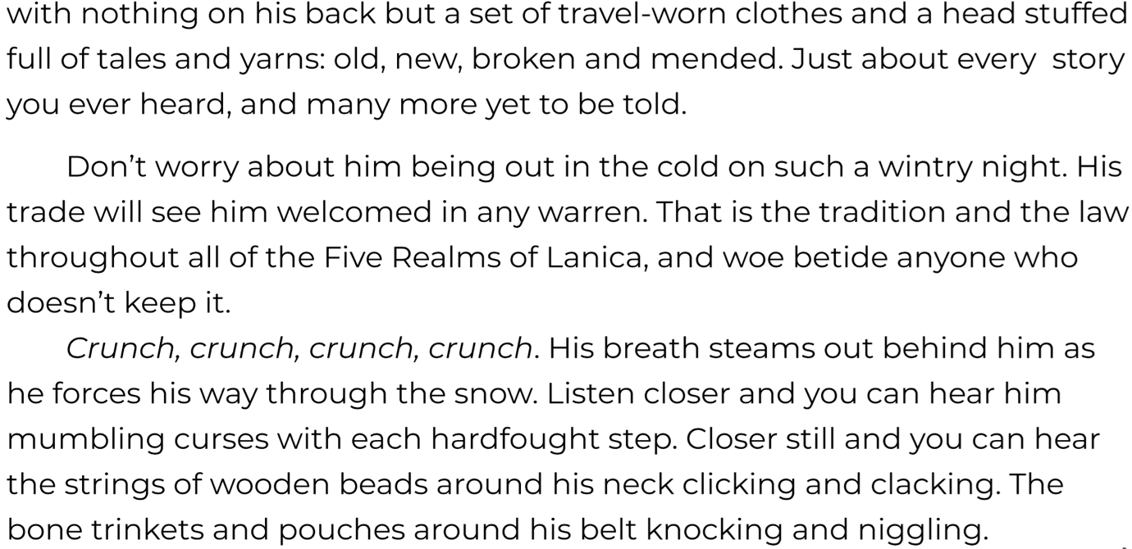
Now answer the questions below about what you have read.
1. Which word is the closest in meaning to ‘hunched’?
weary , tired , cured , old
2. Write a synonym for ‘trod’.
- Which word could the writer have used to replace ‘wanderer’ in paragraph one?
- What does the word betide mean in this sentence?
That is the tradition and the law throughout all of the Five Realms of Lanica,
and woe betide anyone who doesn’t keep it.
- Find and copy a word which means the same as ‘achieved with great effort’.
- Explain the meaning of the word ‘trinkets’ at the bottom of the last paragraph.

